

**BLG439E COMPUTER PROJECT I**

**Project 4 Report**

**by**

**BARAN KAYA - 150130032**

**M. ALİ OSMAN ATİK - 150140804**

**KADİR ENES KARSLIOĞLU - 150130047**

**25.12.2017**

**Table of Contents**

Research and Introduction 2

Motors and drivers 2

Microprocessors 4

Sensors 5

Dedicated Circuits 6

Hardware Design 8

Main Software 10

References 12

Appendix A - An analog circuit for autofocus 13

# Research and Introduction

We investigate some well-known devices for this project and tried to understand what kind of components preferred for production of a camera body and lens. We have focused on main components required for the project such as motors and their drivers, microprocessors, sensors and dedicated circuits.

## Motors and drivers

There are several kinds of motors used in cameras. For simple tasks such as rolling the film or moving the mirror conventional dc motors are still in use. But inside lens body we see some advanced motors such as arc-form motors or ultrasonic motors for sliding lenses and step-motors for electromagnetic diaphragm. Since the diaphragm positions are still in quantized positions in recent designs using step-motors for this task is the best solution.

 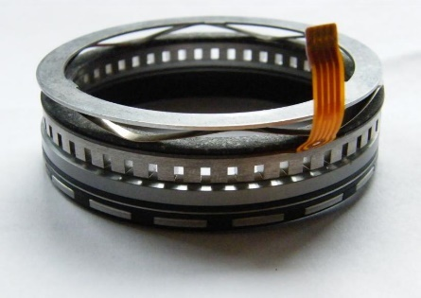 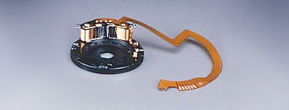

Image – an arc motor, an ultrasonic motor, an electromagnetic diaphragm

Conventional dc motors can be driven by a simple H-Bridge circuit design which can be found in IC form and basically allows us to control the motor in different directions via two-pin interface [1].

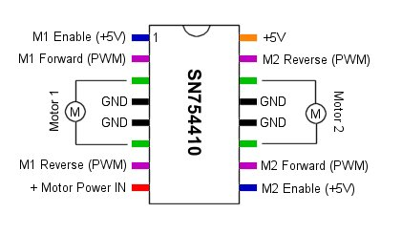

Image – IC for driving 2 motors

Step-motor are drivers requires a system clock because of working as a digital manner such that you can set the rotation of motor to multiples of the angular resolution - step angle - of itself. Step-motor resolutions about 0.360/step are usual.

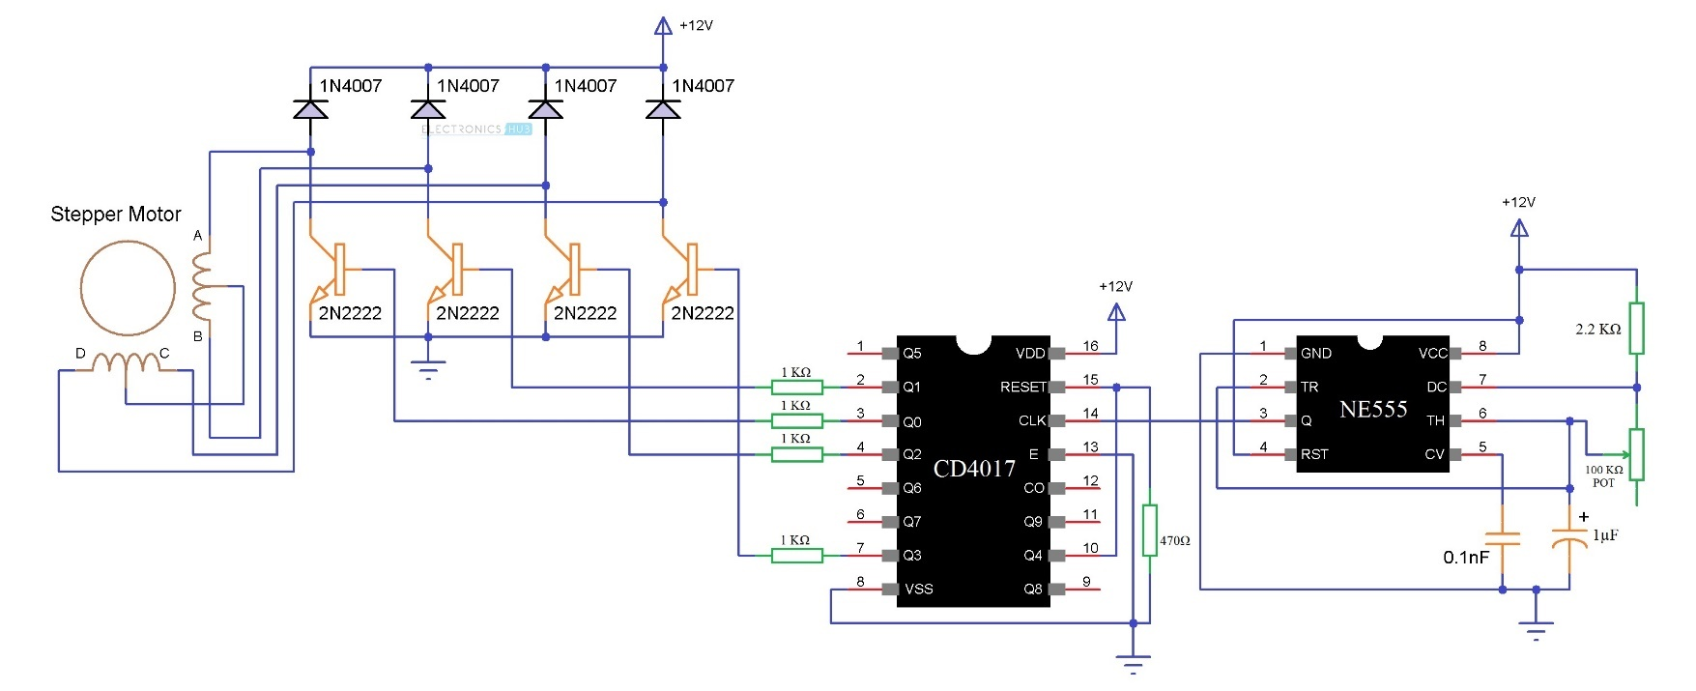

Image - IC driven step-motor

Solenoids are often used for opening and closing shutter gate for a certain amount of time via a control circuit. Actually, same functionality can be achieved with a single solenoid and a spring combination as seen in image 4.

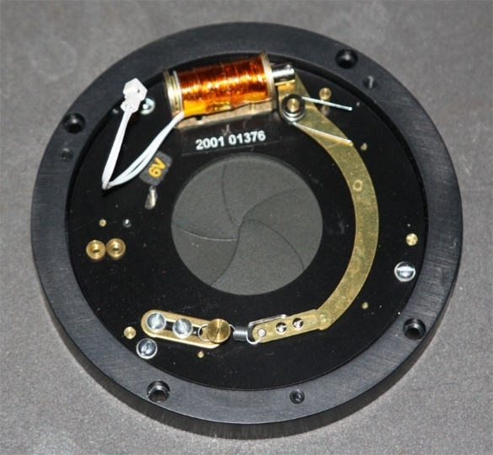 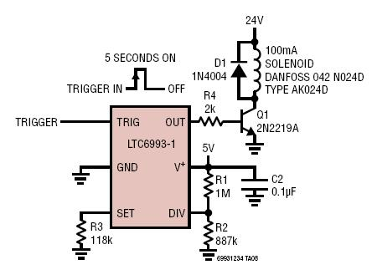

Image - a solenoid controlled shutter and a driver circuit

Leds can be simply driven by *bjt* or *mosfet* transistors in addition of a current limiting resistor. We can actually drive them with logical 1 signal from the microcontroller.

## Microprocessors

For physical requirements in practice we should need small microcontrollers that fits into camera lens housing but for a conceptual camera design, we can make use of a known microcontroller like the one we learned and used in our lessons, one of them is *Texas Instruments MSP430* but theone we chose for the project is *Motorola 6802:*

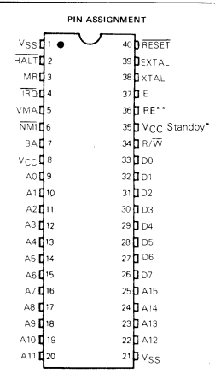

● On-Chip Clock Circuit

● 128x8 Bit On-Chip RAM

● 32 Bytes of RAM are Retainable

● Software-Compatible with the MC6800

● Expandable to 64K Words

● Standard TTL-Compatible Inputs and Outputs

● 8-Bit Word Size

●16-bit Memory Addressing

● Interrupt capability

Image - Motorola 6802

*Motorola 6802 Registers:*

* Program Counter: The program counter is a two byte (16-bit) register that points to the current program address.
* Stack Pointer: The stack pointer is two bytes register that contains the address of the next available location in an external pushdown/pop-up stack. This stack is normally a random access read/write memory that may have any location.
* Address Bus (A0 to A15): When the microprocessor unit reads / writes from the memory unit to address 64 KB of memory space, it exports the 16-bit address information as if it were from sixteen states (A0 to A15).
* Data Bus (D0-D7): The microprocessor unit uses these three-state eight pins (D0-D7) to provide 8-bit data input and output while reading / writing from the memory unit. Data buses are simply referred to as data buses.
* Index Register: This is a 2-byte register that is used for storing data or a 16-bit memory address for the indexed mode of memory addressing.
* Accumulators: The MPU contains two 8-bit accumulators that are used for holding operands and results from an arithmetic logic unit.
* Restart pin(RES): It is used to condition of arithmetic unit initial state. When this bit is set to 0, the program branches to the start address of the microprocessor.
* Interrupt Pin(IRQ): It is determined with interrupt bit on CCR. If this bit is 0, then response to interrupt request. Otherwise, interrupt request is invalid.

## Sensors

Lens position can be determined by incremental linear encoders, absolute rotary encoders or optical encoders [2]. There are magnetic and hall effect sensory alternatives of these mechanisms. An 8-bit encoders output gives the location of lens with a 25mm freedom of movement, about 0.1mm precision.

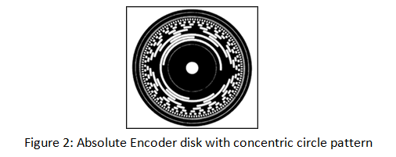 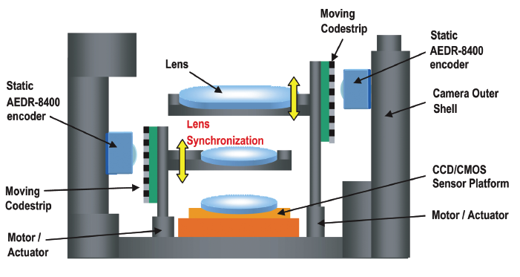

Image - 8-bit absolute rotary encoder, AEDR-8400 optical encoder

Autofocus sensors measures the light intensity on some points and autofocus calculations are done according to their output values. Modern sensors use phase detection techniques for better results [3].

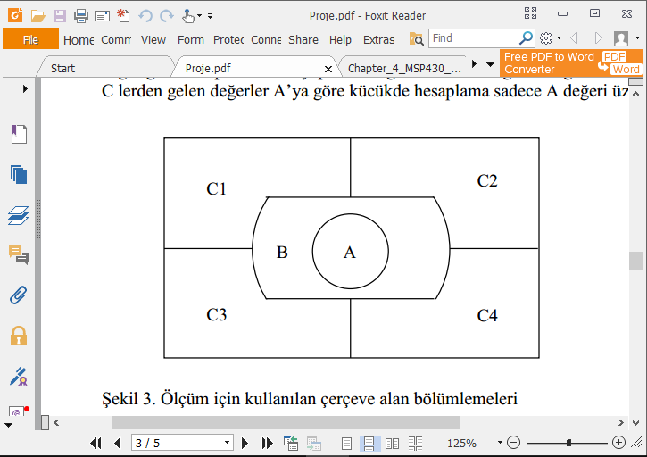 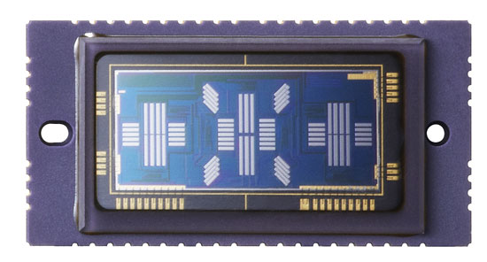

Image - our projects sensor diagram with 6 points, a modern autofocus sensor with 76 points

## Dedicated Circuits

For battery test we modified a well-known circuit with LM3914 and reduced it to three state indicators led and add an out pin for low battery signal.

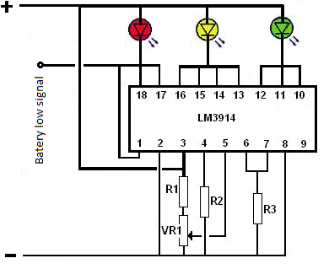

Image - Our battery tester design

Sound may be needed for simple failure alerts. For this purpose, instead of complicated sound circuits we used a simple piezo buzzer which we can be driven with a transistor and use the clock signal or its variations as input signal. An extra transistor is used for enabling the circuit from microcontroller.

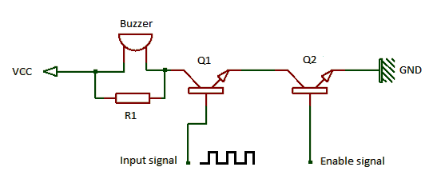

Image - Our simple sound circuit design with buzzer

Autofocus calculations can be done with an analog circuit, there is an example of a patented design for a microscope system [4] on *Appendix A*.

# Hardware Design

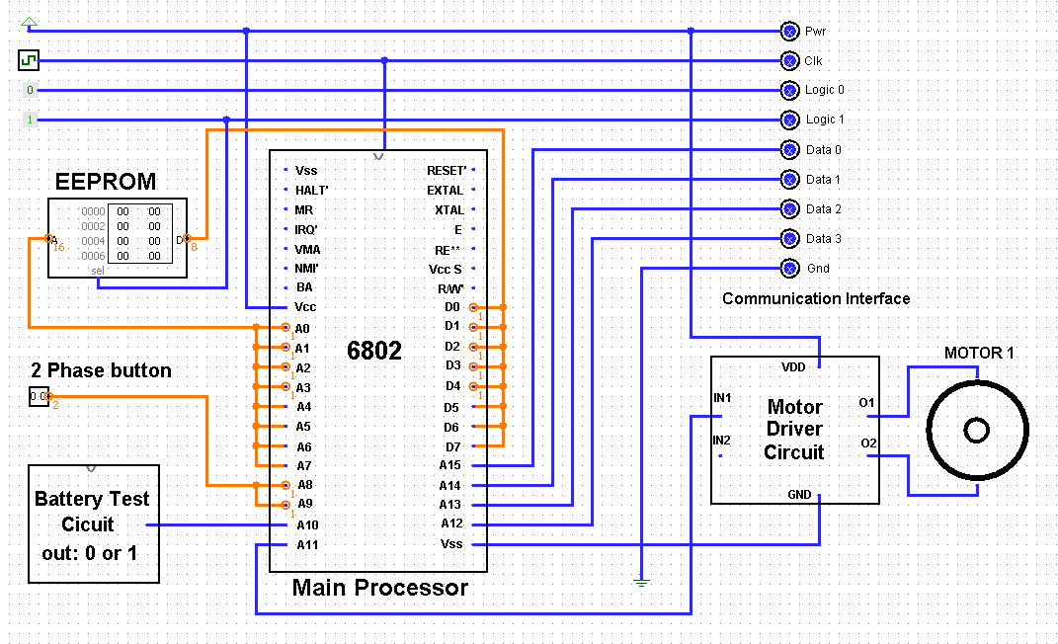

Figure - Our conceptual hardware design for camera body

* State of the battery read from A10 pin via “Battery low signal” on our design
* Phase of the déclencher button read from A8-a9 pins
* EEPROM addresses read from A0-A7 pin
* EEPROM data transfer made through D0-D7 pins
* Motor 1 for rolling the film activated via pin A11
* Communication with lens made through A12-A15 pins
* Logical 0, 1, Pwr and Gnd voltages and Clk signal are also sent through communication interface

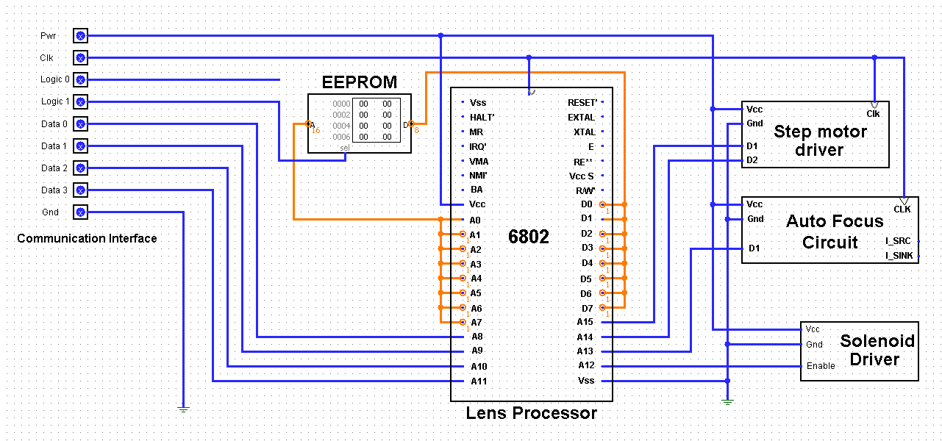

Figure - Our conceptual hardware design for lens body

* Communication with camera body made through A8-A11 pins
* EEPROM addresses read from A0-A7 pin
* EEPROM data transfer made through D0-D7 pins
* Solenoid driver for shutter gate is controlled via pin A12
* Stepper motor driver for exposure is controlled via pin A14-A15
* Result of autofocus circuit is read from pin A13

# Main Software

START

STA Battery circuits result in ACC A

BEQ FINISH (if result is 1 continue, else go to FINISH)

(branch if zero)

CONT1

STA Button's result (0->not pressed, 1->phase 1, 2->phase 2)

CMPA 1 (If button is in phase 1)

JMP CONT2 (if)

JMP FINISH (else)

CONT2

CALL AUTOFOCUS

CALL AUTOEXPOSURE

STA Button's result (0->not pressed, 1->phase 1, 2->phase 2)

CMPA 2 (If button is in phase 2)

JMP CONT3 (continue)

JMP CONT1 (go to 2 steps backward)

CONT3

STA Battery circuits result in ACC A

BEQ FINISH (if result is 1 continue, else go to FINISH)

(branch if zero)

STA Button's result (0->not pressed, 1->phase 1, 2->phase 2)

CMPA 1 (If button is in phase 2)

JMP CONT1 (if button is in phase 1)

JMP CONT4

CONT4

CALL EXPOSURE (Stores its result in memory)

CALL MIRRORMOTORSUP

CALL LPDCM (Lens Processor Diaphragm Control Motor)

CMP $3333 0 (If exposure is not valid go to CONT4 and try it again)

JMP CONT4

CALL LPOEV (Lens Processor Open Exposure Valve)

CALL LPW (Lens Processor Waiting for Exposure)

CALL LPCEV (Lens Processor Close Exposure Valve)

CALL LPOD (Lens Processor Open Diaphragm)

CALL MIRRORMOTORSDOWN

CALL STOPMOTORS

CALL SAVEPICTURE

JMP START

FINISH

# References

**[1]** SN754410, H. (2017). *H-Bridge Motor Driver 1A - SN754410 | COM-00315 | Texas Instruments*. [online] Hobbytronics.co.uk. Available at: http://www.hobbytronics.co.uk/h-bridge-driver-sn754410

**[2]** Digikey.lu. (2017). *Advantages of an Optical Encoder | DigiKey*. [online] Available at: https://www.digikey.lu/en/articles/techzone/2011/may/advantages-of-an-optical-encoder

**[3]** Northlight Images. (2017). *Canon EOS 5D Mark 3 information*. [online] Available at: http://www.northlight-images.co.uk/canon-eos-5d-mark-3-information/

**[4]** *Patent USRE40674 - Analog circuit for an autofocus microscope system*. [online] Available at: https://www.google.com/patents/USRE40674

# Appendix A - An analog circuit for autofocus

